## Making camera calibration images

The goal is to take pictures of objects of known size at a range of known distances from the camera in order to calculate the camera’s intrinsic properties, which then allow us to calculate the positions of objects of known size, as used in site calibration. This needs to be done for each combination of camera model and image resolution setting used in the field Note: it’s best to keep image resolution consistent throughout; if you do this, and use a consistent camera model, you only need to calibrate one camera. The steps are as follows:

1. Make a calibration pole, with regular length intervals clearly marked. A 1 m pole with 20 cm intervals marked works well (Fig. 1). Note that the gradations on this pole are indicated by the number of bands, so for example, the top of the triple band is at 60 cm from the tip, whereas the single band is at 20 cm.
2. On an open arena, mark out nine or more positions at a range of different radial and angular distances from the camera, measuring the distances from camera accurately. Fig. 2 gives an example of placement positions, with poles at three distances (1, 2 and 4 m), and a range of angles. It’s not necessary to measure angle, but it should be variable, and within the camera’s field of view (usually about 20 degrees either side of the mid line, but you may need to check the effective field of view for your camera and setting).
3. With a camera positioned in front of the arena and switched on, take one image of the pole at each position on the array, holding up some visible marker of the distance. For example, in Fig. 1, the pole is placed at 2 m from the camera, with distance indicated in metres by the number of fingers displayed.

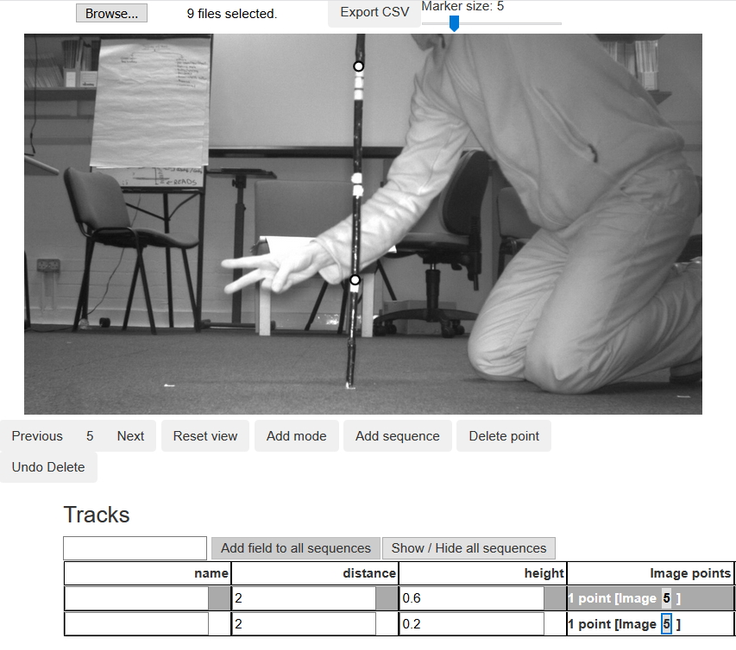

Fig. 1. A camera calibration image with pole in position 2 m from the camera, and two postions digitised at given heights.

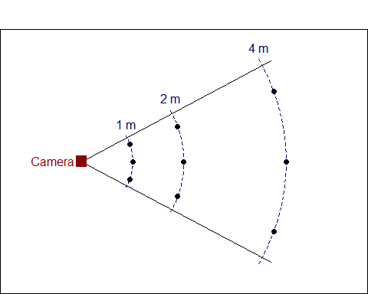

Fig. 2. Diagram of an example layout for a camera calibration pole grid.